Technical Datasheet WIN-SN-8N1-ENV-M Sensor

The Sensor Unit collects the environmental data of 8 parameters from the indoor surrounding and displays the data as well as sends the data to the Cloud over MODBUS protocol over WI-FI.The unit is robustly designed for continuous 24/7 operation and is exceptionally easy to use.

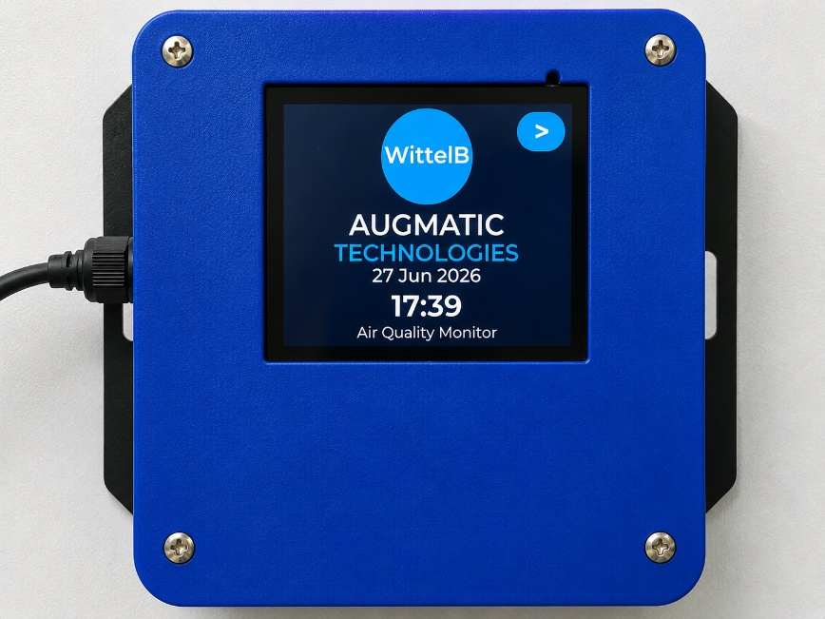
Display Module: -

The module is housed in a rugged industrial enclosure with wall mounting slots featuring an integrated display for easy installation deployment. Configuration settings such as Wi-Fi connectivity, MODBUS communication can be managed through the integrated display interface or the built-in web portal.
The modules are designed for reliable long-term operation with built-in protection, ensuring enhanced safety and system reliability. The Display Unit collects, displays, and securely publishes sensor data to the cloud using the MODBUS protocol, enabling continuous remote monitoring and data access.

Specifications
General –
Dimensions 98 mm L x 98 mm B x 34 mm H
Power Input Power – 5 VDC Type C
Operating Temperature -20°C to +80°C (-4°F to +176°F)
Storage temperature -20°C to +80°C (-4°F to +176°F)

Storage Humidity 5 ~ 95 % RH, non – Condensing
Certifications

Operator Interface & Navigation Guide

1. Initial Network Provisioning (Wi-Fi Setup):
Upon first boot—or when a network change is required—the device enters Access Point (AP) mode. The screen displays a "Wi-Fi Setup Required" prompt, broadcasting its own local network. Users simply connect to this network via a mobile device or laptop using the Password 12345678 and navigate to the provided IP address (ex: 192.168.4.1) to securely pass local Wi-Fi credentials to the unit.
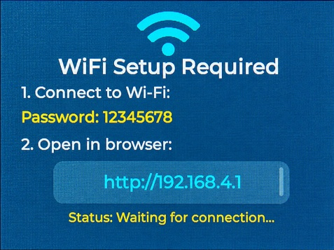

2. Home Screen & Main Navigation
Once provisioned, the device boots to the Home Screen, displaying the company logo, current date/time, and system title. Tapping the [ > ] icon in the top right corner opens the Main Menu, which splits the interface into two primary pathways:
- AQI Dashboard: For live data of the sensors.
- MODBUS Dashboard: Indicates the current details modbus
- WIFI Settings : Configure the device whenever the Wi-Fi network changes.
- MODBUS Setup: Configuration settings for the MODBUS Connections.

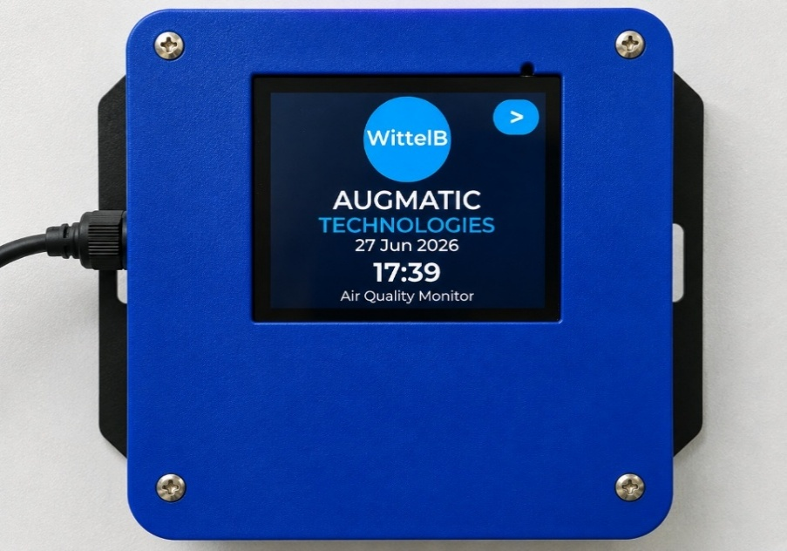
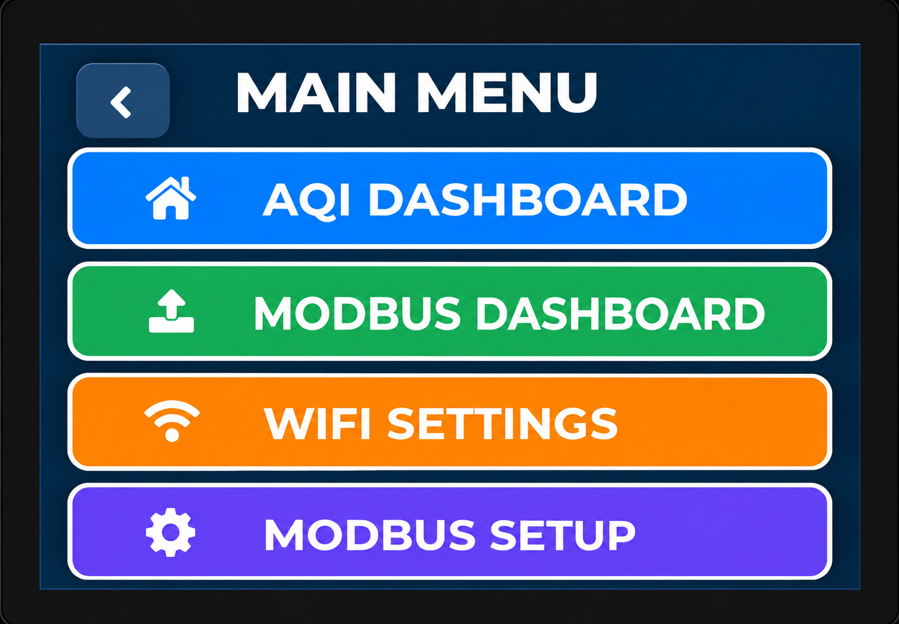

3. Live Telemetry Dashboard
The Dashboard provides a clear, real-time view of all monitored air quality parameters on a single screen, enabling users to quickly assess the current environmental conditions.
- Real-Time Monitoring: Displays the latest values of all connected sensors, including Temperature, Humidity, PM1.0, PM2.5, PM10, CO2, AQI, and TVOC.
- Color-Coded Display: Each parameter is presented in a dedicated color-coded tile for improved readability and quick identification.
- Instant Data Updates: Sensor readings are refreshed continuously, providing up-to-date information for effective environmental monitoring.
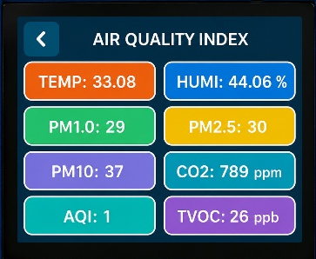
- User-Friendly Interface: The intuitive display allows users to easily view and monitor all air quality parameters from a single dashboard screen.

4. MODBUS Status & Configuration
The MODBUS interface provides a clear, real-time overview of the device's modbus connectivity and data transmission settings, enabling users to easily verify their network parameters and current connection state
- Baud Rate Configuration: Displays the active serial communication speed (e.g., 9600) in a dedicated color-coded tile to quickly verify the RS485 transmission rate.
- Slave ID Assignment: Shows the designated Modbus address (e.g., 1) that the device is currently configured to communicate with on the network.
- Parity Bit Settings: Displays the active parity configuration (e.g., 3) defining the error-checking method used during Modbus data transmission.
- Stop Bit Indicator: Indicates the configured number of stop bits (e.g., 1) used to signal the end of a data packet in the serial communication.
- Web-Based Setup: The setup screen displays the active Wi-Fi network (e.g., WittelB) and provides a direct local IP address (e.g., http://192.168.1.60). Users simply enter this IP into a mobile or PC browser to securely access the web portal and configure the MODBUS parameters.
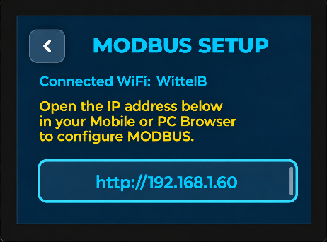
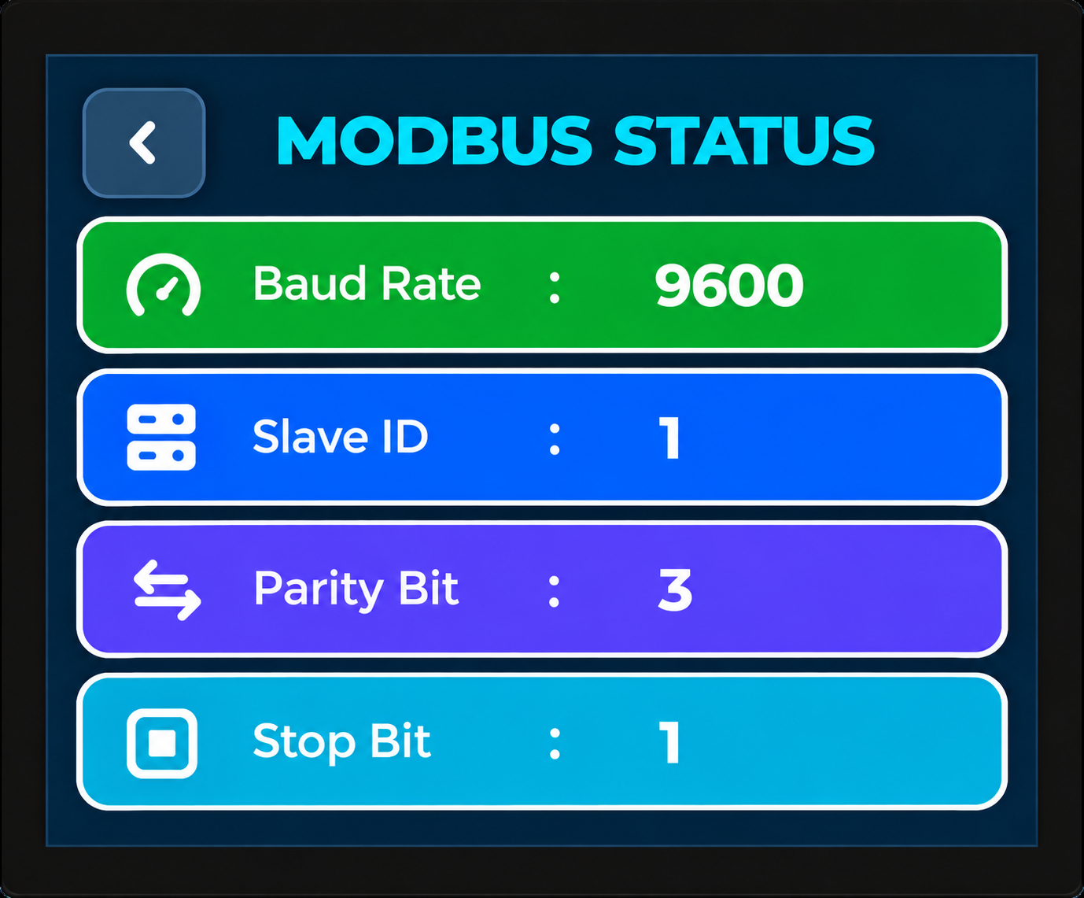

Web Portal Configuration Guide
1. Accessing the Wi-Fi Manager
- Navigating to the device's IP address opens the main WIFI Manager portal.
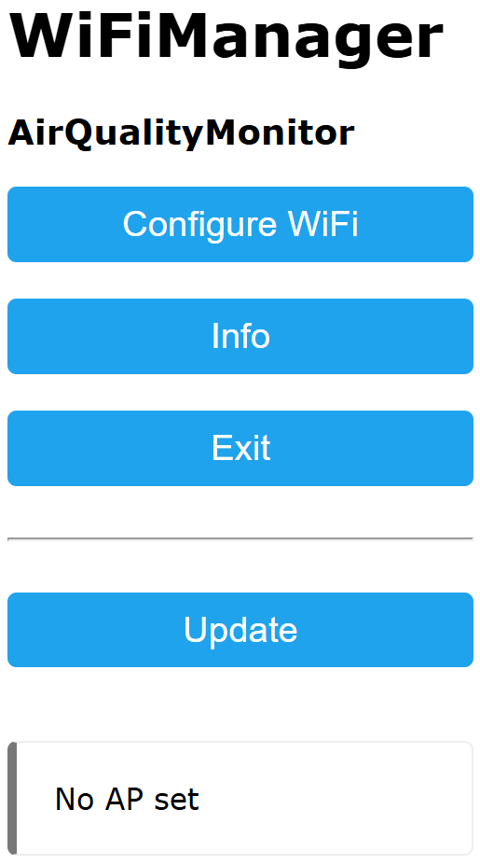
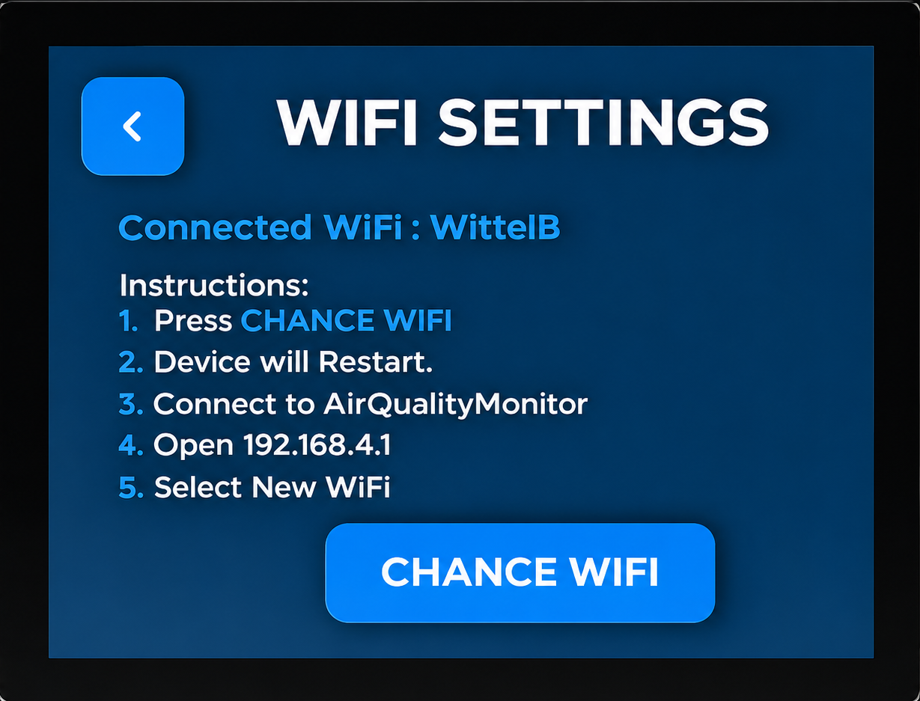
- Click the [Configure Wi-Fi] button to proceed to the network selection page.

2. Selecting the Network
- The setup page displays a list of available Wi-Fi networks in range.
- Tap the desired network from the list to automatically populate the SSID input field or type the SSID manually.
- Enter the network security key into the Password input field.
- Click the Save button to commit the credentials.
- The device will then process the information and connect to the assigned Wi-Fi network.
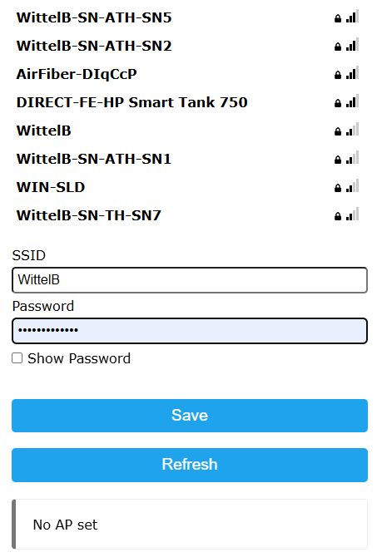

MOSBUS Register Configuration

ID | Function  Description | Register  Description | Modbus Function Code | Protocol | Data  Type
1 | Temperature | 40001 | 0X03 | RS485 | 16 Bit Unsigned int
2 | Humidity | 40002 | 0X03 | RS485 | 16 Bit Unsigned int
3 | PM1.0 | 40003 | 0X03 | RS485 | 16 Bit Unsigned int
4 | PM2.5 | 40004 | 0X03 | RS485 | 16 Bit Unsigned int
5 | PM10 | 40005 | 0X03 | RS485 | 16 Bit Unsigned int
6 | CO2 | 40006 | 0X03 | RS485 | 16 Bit Unsigned int
7 | AQI | 40007 | 0X03 | RS485 | 16 Bit Unsigned int
8 | TVOC | 40008 | 0X03 | RS485 | 16 Bit Unsigned int
9 | Display Baud Rate (Default:960) | 40011 | 0x03 | RS485 | 16 Bit Unsigned int
10 | Enter New Baud Rate | 40012 | 0x03 | RS485 | 16 Bit Unsigned int
11 | Display Slave ID (Default:1) | 40013 | 0x03 | RS485 | 16 Bit Unsigned int
12 | Enter New Slave ID | 40014 | 0x03 | RS485 | 16 Bit Unsigned int
13 | Display Parity  (Default: None-3, Odd-1, Even-2) | 40015 | 0x03 | RS485 | 16 Bit Unsigned int
14 | Enter New Parity | 40016 | 0x03 | RS485 | 16 Bit Unsigned int
15 | Display Stop Bit  (start-2/stop bit-1) | 40017 | 0x03 | RS485 | 16 Bit Unsigned int
16 | Enter New Stop Bit | 40018 | 0x03 | RS485 | 16 Bit Unsigned int
17 | Save Modbus Settings | 40019 | 0x03 | RS485 | 16 Bit Unsigned int
18 | Reset Modbus Settings | 40020 | 0x03 | RS485 | 16 Bit Unsigned int

MODBUS Mbpoll Configuration
- Here is an example of receiving data on Mb poll software.
- Open Mb-poll software connect using configuration setting (Default baud rate is 9600 and slave id is 1.
- After connecting you will get data as shown below
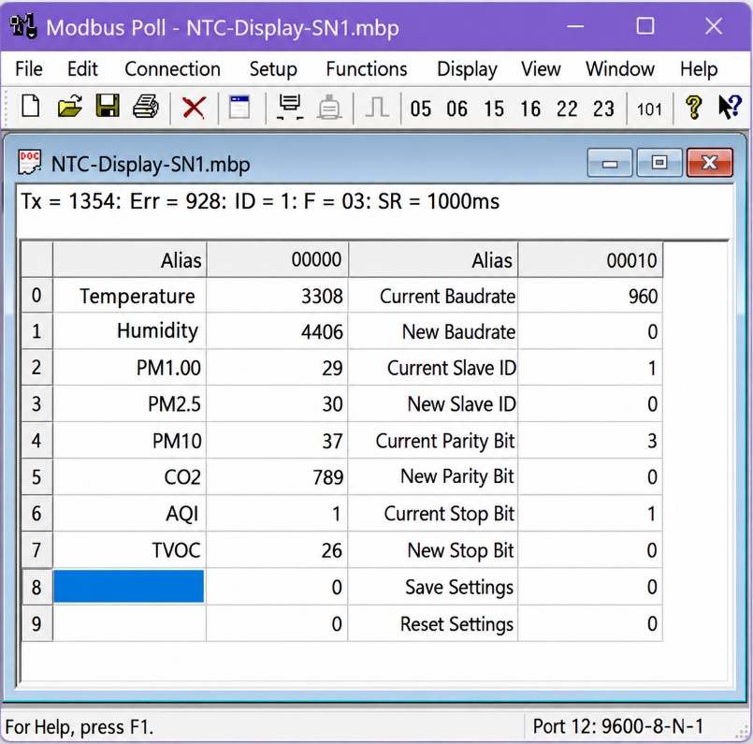
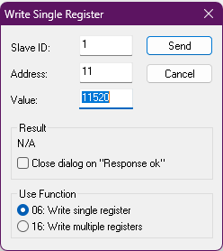
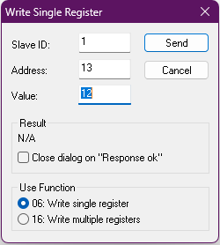
- As you can see in the image above, the resistor 40010 – 960 represents the present bund rate (9600) of the board and 40012 – 1 represents the present slave id of the board.

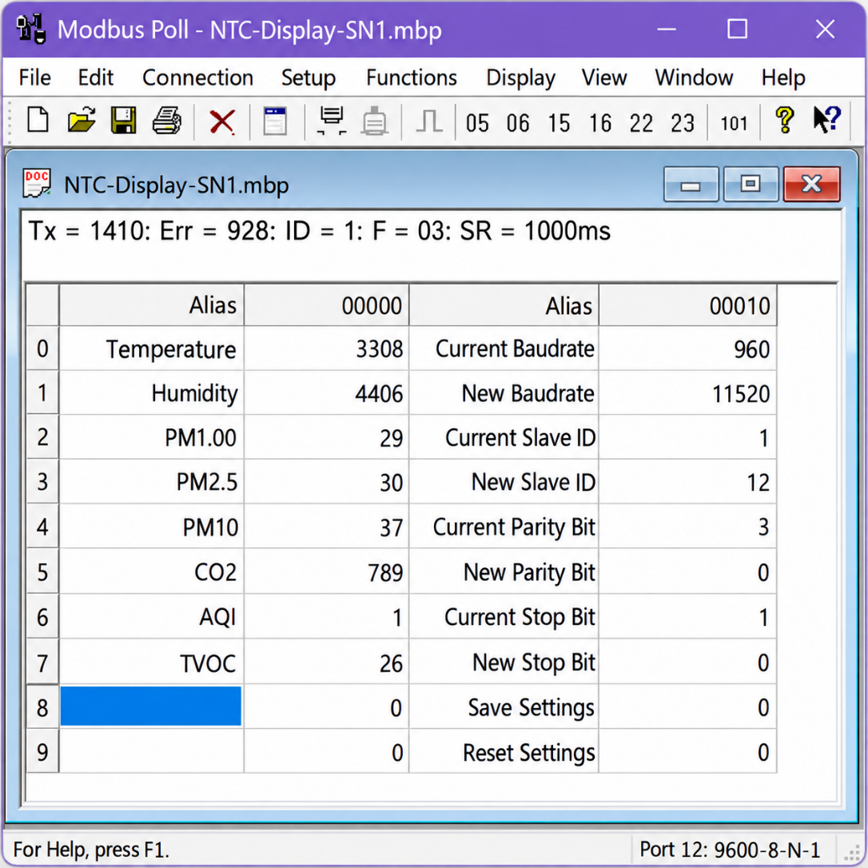
- To change the baud rate and slave id you must enter a value on the 40011 resistors for the baud rate and 40013 for the slave id as shown in the image below.

- After that, press the SAVE button located in the Modbus Settings screen on the display, or remotely write a value of 1 to Modbus register 40019.
- If you want to enter the baud rate 9600/19200/38400/57600/115200etc. Enter it like this 960/1920/5760/11520etc.
- Modbus Integer Scaling: To preserve precision, all decimal sensor values are sent as whole numbers. Divide the raw register reading by its scale factor (e.g., 100) to calculate the actual value (e.g., a reading of 3308 represents 33.08 °C).
  - Temperature : °C
  - Humidity : % (or % RH for Relative Humidity)
  - CO2 : ppm (Parts Per Million)
  - PM1.0 / PM2.5 / PM10 : µg/m³ (Micrograms per cubic meter)
  - AQI : Index (Unitless scale, typically 1 - 5)
  - TVOC : ppb (Parts Per Billion) or mg/m³

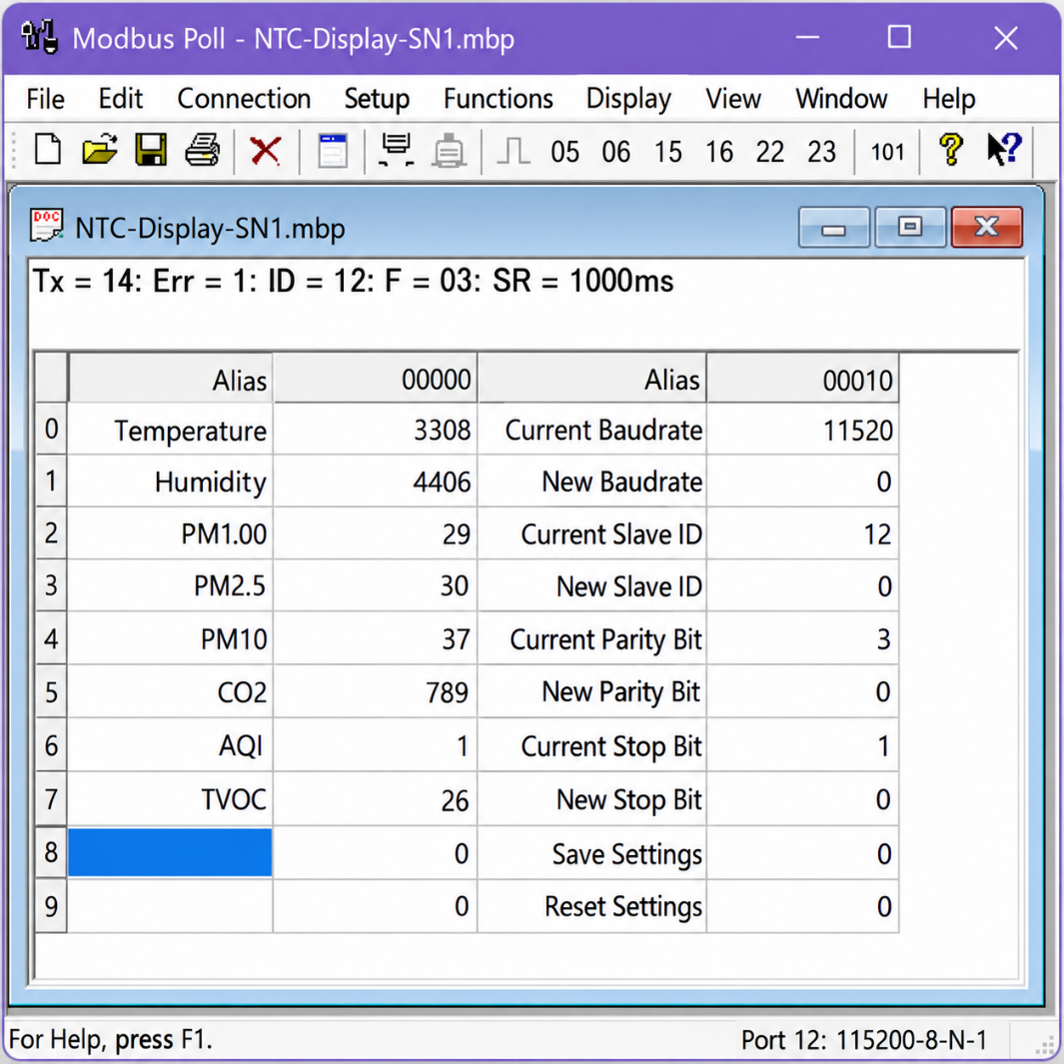
- Then you will get the present value of 11520 at 40011 baud rate(115200) and 12 at 40013 slave id.

- Network Parameter Recovery: In the event of lost communication parameters, factory default settings (9600 Baud, Slave ID 1) can be instantly restored.
- Either press the RESET button within the touchscreen's Modbus Settings interface or remotely write a value of 1 to Modbus holding register 40020.

Contact us: -
Augmatic Technologies Pvt. Ltd.,
Plot no 6, Shah Industrial Estate II,
Kotambi,
Vadodara – 391510.
Email – Sales@wittelb.com
Support: support@wittelb.raiseaticket.com / +91 94038 92805

